

**Convertrite Installation Guide (V1.2)**

**Table of Contents**

Convertrite 2

Convertrite Application Server Setup 3

NGINX INSTALLATION & CONFIGURATION 3

CONVERTRITE APPLICATION CONFIGURATION 5

Directory Config 5

CLOUD Integrator Setup 6

Convertrite Service Creation 6

Create a service file 7

Start ConvertRite Service 7

ORACLE DATABASE-19C INSTALLATION 8

Additional Setup 9

Java Installation 12

DBCA configuration 13

# Convertrite

ConvertRite is a secure, HIPAA-compliant Oracle Data Conversion Tools built on Oracle PaaS, designed to automate Data Conversion from any ERP to Oracle Cloud Applications. With ConvertRite, you can automate manual, time-consuming and error-prone processes (such as data mapping and validation) and accelerate data migration from legacy system to [Oracle Cloud](https://www.ritesoftware.com/services/applications/) [Application](https://www.ritesoftware.com/services/applications/).

Convertrite major benefits ,

* Effective –mapping source data to FBDI/HDL format
* Iterative approach to load and improve data – quantity and quality
* Effort reduction in performing reconciliation activity between source system and SaaS



## Convertrite Application Server Setup

Page 3 of 14

[www.ritesoftware.com](http://www.ritesoftware.com/) | © Rite Software 2021 | All Rights Reserved

**PRE-REQUISITES**:

**OS**: Oracle Linux Server Version ="8.6"

**STORAGE**: 500GB

**RAM**: 16GB

**CPU’s**: 4

### Create a User with SUDO Permissions:

# useradd convertrite # passwd convertrite # su - convertrite

### NGINX INSTALLATION & CONFIGURATION:

$ sudo yum install nginx -y

$ cd /etc/nginx/

$ sudo mkdir sites-available sites-enabled

$ sudo vi sites-available/convertrite.conf

server {

listen 80 default_server;

listen [::]:80;

server_name crsaas1.ritesoftware.com;

root /usr/share/nginx/html/crdev;

index index.html;

location /

{

try_files index.html $uri $uri/ /index.html;

}

location /ConvertRiteSpringBootApiDev{ proxy_pass http://127.0.0.1:9091/;

}

}

server {

listen 443 ssl http2 default_server; listen [::]:443 ssl http2; server_name crsaas1.ritesoftware.com;

root /usr/share/nginx/html/crdev;

ssl_certificate "**ssl certificate path**"; ssl_certificate_key "**SSL certificate key path**";

location /ConvertRiteSpringBootApiDev { proxy_pass http://127.0.0.1:9091/;

}

location /

{

try_files index.html $uri $uri/ /index.html;

}

ssl_protocols TLSv1.2 TLSv1.1 TLSv1;

[}](http://www.ritesoftware.com/)

* Save and exit.
* **Create a Link File**

$ ln -s /etc/nginx/sites-available/convertrite.conf /etc/nginx/sites- enabled/

* **Insert the below line under http tag in ngnix configuration file**

$ vi /etc/nginx/nginx.conf

include /etc/nginx/sites-enabled/*.conf;

proxy_read_timeout 3000;

fastcgi_read_timeout 3000;

client_max_body_size 100G;

types_hash_max_size 4096;

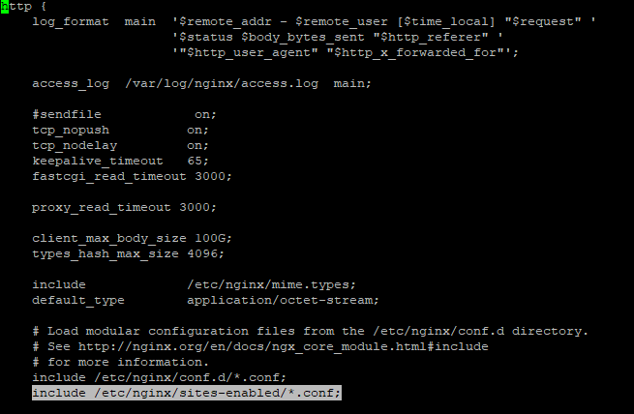

* Comment all the lines from “**server {**“ till last line because we did all the server configuration in “sites-available/convertrite.conf” file.
* If we don’t comment server tag in nginx.conf file nginx don’t pick “sites-available/convertrite.conf” file.
  + Save and exit.
  + To check nginx configuration errors follow this command.

$ sudo nginx -t

* + Now create a directory called CONVERTRITE in the following path.

$ mkdir /usr/share/nginx/html/convertrite

* + Place the Convertrite UI files (CSS, JS,INDEX.HTML) in the above path using WINSCP OR SCP
  + **Now start the nginx server**

$ sudo systemctl enable nginx

$ sudo systemctl start nginx

$ sudo systemctl status nginx

* Set secure Linux to permissive by editing the "/etc/selinux/config" file, making sure the SELINUX flag is set as follows.

SELINUX=permissive

* Once the change is complete, restart the server or run the following command.

# setenforce Permissive

## CONVERTRITE APPLICATION CONFIGURATION

#### Directory Config:

$ mkdir external_properties convertrite_jar crlogs cloud_connector

$ cd cr_external_properties

$ vi external.properties

logging.file.name=<**LOGFILE PATH>** application.log

# Oracle settings spring.datasource.url=jdbc:oracle:thin:@//<DB SERVER IP>:1521/<SERVICE NAME>

spring.datasource.username=<DB USERNAME> spring.datasource.password=<DB PASSWORD>

spring.datasource.driver-class-name=oracle.jdbc.driver.OracleDriver

datasource.hostname=<DB SERVER IP> datasource.port=1521 datasource.sid= <SID>

file.upload-dir=<Dir PATH>/Data

(Create this dir in DB server)

#SFTP Server Details sftp.client.host=<SFTP SERVER IP> sftp.client.username=<SERVER USERNAME> sftp.client.password=<SERVER PASSWORD>

file.upload.dir.oracle=/home/oracle/G2N_TAB_MAIN

(Create this dir in DB server)

server.port=9091

context-path=/ConvertRiteSpringBootApiDev application-hostname=<Application SERVER IP>

clouddataprocess-url=https://<Host name>/ConvertRiteSpringBootApiDev/ clouddataprocessingrequest

syncsaasdata-url=https://<Host name>/ ConvertRiteSpringBootApiDev/synccloudinterfacedata

import-callback-url=http://<APP server Public IP>:9091/callback

* Make sure that **File upload directory ”Data and G2N_TAB_MAIN”** have full permissions.
* Now place the application jar in /home/convertrite/crdev_jar directory using winscp or scp

### CLOUD Connector Setup

* First, we need to create a Directory in cloud_connector

$ mkdir -p /home/convertrite/cloud_connector/config

* Now create a file called ‘application.properties’ in ‘config’
* Mention below details in application.properties

$ vi cloud_connector/config/ application.properties

#security-service-url=https://ucf5-zsjk-fa- ext.oracledemos.com/xmlpserver/services/v2/SecurityService security-service-url=/xmlpserver/services/v2/SecurityService #catalog-service-url=https://ucf5-zsjk-fa- ext.oracledemos.com/xmlpserver/services/v2/CatalogService catalog-service-url=/xmlpserver/services/v2/CatalogService #report-service-url=https://ucf5-zsjk-fa- ext.oracledemos.com/xmlpserver/services/v2/ReportService report-service-url=/xmlpserver/services/v2/ReportService absolute-path=/~linda.cairns/ConverRiteTest

datasource.hostname= <DB SERVER IP> datasource.port=1521

datasource.name= <SID OR SERVICE NAME> datasource.username= <DB USER> datasource.password=<DB USER PASSWORD>

file-upload-dir= <GIVE DIR PATH>

sftp-client-host=<SFTP SERVER PATH> sftp-client-username=<SFTP USER>

sftp-client-password=<SFTP USER PASSWORD> thread-sleep-time=60000

* + Save and exit
* Now Place the cloud connector jar in **cloud_connector** directory Using Winscp or SCP



**Cloud connector service Creation**

* . Create a shell script file in cloud-connector Directory

$ vi cloud-connector/cloudconnector.sh

#!/bin/bash

cd /home/convertrite/cloud_connector

java -jar cloudconnectorservice-0.0.1-SNAPSHOT.jar 2>> /dev/null 1>> /dev/null

* + Save and exit

### Convertrite Service Creation

* Create a shell script file in /home/convertrite/convertrite_jar

$ vi /home/convertrite/crdev_jar/convertrite.sh

#!/bin/bash

cd /home/convertrite/convertrite_jar

java -jar -Dspring.profiles.active=<Profile name> convert-rite-api-0.0.1-SNAPSHOT.jar >service.out 2>errors.txt < /dev/null

* Save and exit

$ chmod 777 /home/convertrite/crdev_jar/convertrite.sh

$ chmod 777 /home/convertrite/ cloud_connector/ cloudconnector.sh

### Create service files

$ vi /etc/systemd/system/convertrite.service

[Unit]

Description=Convert Rite Application Service

[Service] User=<Username>

WorkingDirectory=<DIR PATH>

ExecStart=<DIR PATH>/convertrite.sh

Restart=on-failure

SuccessExitStatus=143 TimeoutStopSec=10 RestartSec=5

[Install]

WantedBy=multi-user.target

* + Save and exit

$ vi /etc/systemd/system/ cloudconnector.service

[Unit]

Description= Cloud_connector Service

[Service] User=<Username> WorkingDirectory=<SCRIPT DIR PATH>

ExecStart=<Script DIR PATH>/ cloud-connector.sh

Restart=on-failure SuccessExitStatus=143 TimeoutStopSec=10 RestartSec=5

[Install]

WantedBy=multi-user.target

### Start ConvertRite Service and Cloudconnector service

$ sudo systemctl daemon-reload

$ sudo systemctl start cloudconnector

$ sudo systemctl status cloudconnector

$ sudo systemctl start convertrite

$ sudo systemctl status convertrite

**DATABASE 19C INSTALLATION**

**PRE-REQUISITES** **FOR ORACLE 19C DATABASE**

* **OS**: Oracle Linux Server VERSION="8.6"
* **STORAGE**:550G (100-Boot volume, /u01=100G-Software, /u02=350G-Databse files)
* **RAM**:64GB
* **CPU’s**: 4
* **SWAP SPACE**:16GB
* Download oracle Database 19c Enterprise Edition from <https://edelivery.oracle.com/>

**Note:** If you don’t have a Oracle account please create a oracle account to download the Database

* Find the pictures below for your reference

* Download and move the zip file to **/tmp** in target server

**CONNECT TO THE SERVER IN MOBAXTERM**

* Before starting the Database installation, we need to install the following packages

$ sudo dnf install oracle-database-preinstall-19c

$sudo dnf install xorg-x11-apps

* Now create a password to ORACLE user

$ passwd oracle

* Go to SSH configuration file and uncomment and change the value from NO to YES to ForwardX11
* Now create the following mount points(Directory’s)

$ sudo mkdir /u01 /u02

$ sudo chown -R oracle:oinstall /u01 /u02

$ touch /home/oracle/.Xauthority

$ echo $DISPLAY

$ xauth add crdev-db19c/unix:13 MIT-MAGIC-COOKIE-1 6e0f219433811c4cb35a374a719d6b1e

$ export DISPLAY=localhost:13.0

$ xhost +

$ sudo cp /tmp/V982063-01.zip /u02

$ unzip V982063-01.zip

$ export ORACLE_BASE=/u01/app/oracle

$ export ORACLE_HOME=/u01/app/oracle/product/19.0.0/db1

$ export CV_ASSUME_DISTID=OEL7.8

$ cd /u02

$ ./runInstaller

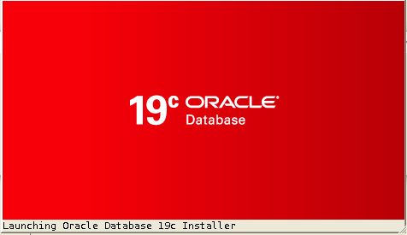

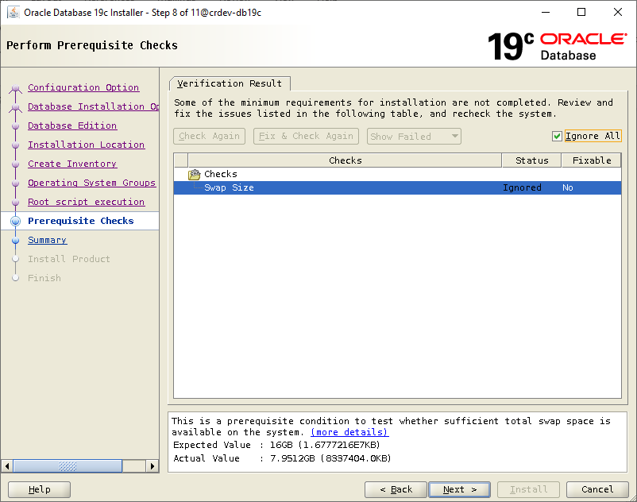

|  |
| --- |
| * This is a prerequisite condition to test whether sufficient total swap space is available on the system. (more details) * Expected Value : 16GB (1.6777216E7KB) * Actual Value : 7.9512GB (8337404.0KB) |

* We can ignore this error and continue Click on yes

* **Execute Root scripts in CLI:**

By default, root.sh file will store’s in $ORACLE_HOME

$ /u01/app/oracle/product/19.0.0/db1/root.sh

**Output:**

|  |
| --- |
| Performing root user operation.  The following environment variables are set as:  ORACLE_OWNER= oracle  ORACLE_HOME= /u01/app/oracle/product/19.0.0/db1  Enter the full pathname of the local bin directory: [/usr/local/bin]:  The contents of "dbhome" have not changed. No need to overwrite.  The contents of "oraenv" have not changed. No need to overwrite.  The contents of "coraenv" have not changed. No need to overwrite.  Entries will be added to the /etc/oratab file as needed by  Database Configuration Assistant when a database is created  Finished running generic part of root script.  Now product-specific root actions will be performed.  Oracle Trace File Analyzer (TFA - Standalone Mode) is available at :  /u01/app/oracle/product/19.0.0/db1/bin/tfactl  Note :  1. tfactl will use TFA Service if that service is running, and user has been granted access  2. tfactl will configure TFA Standalone Mode only if user has no access to TFA Service or TFA is not installed |

**DBCA Configuration:**

$ cd /u01/app/oracle/product/19.0.0/db1/bin/

$ ./dbca

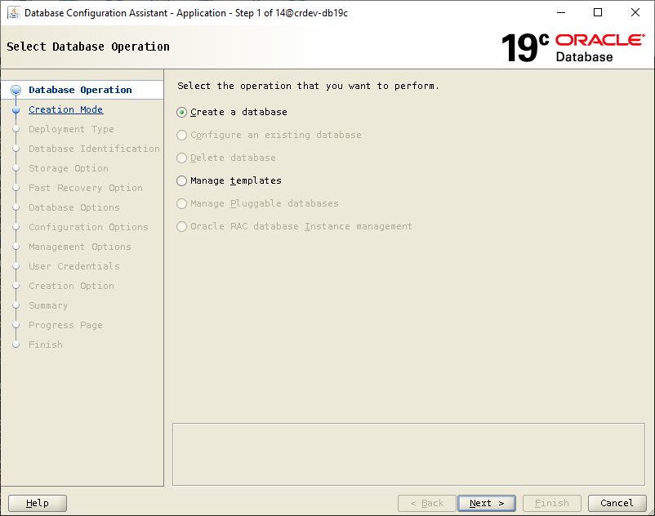

**DATABASE IDENTIFICATION DETAILS**:

**GLOBAL DATABASE NAME**: Hostname

**SID :** Give a SID

* **Database File location: /u02/oradata**

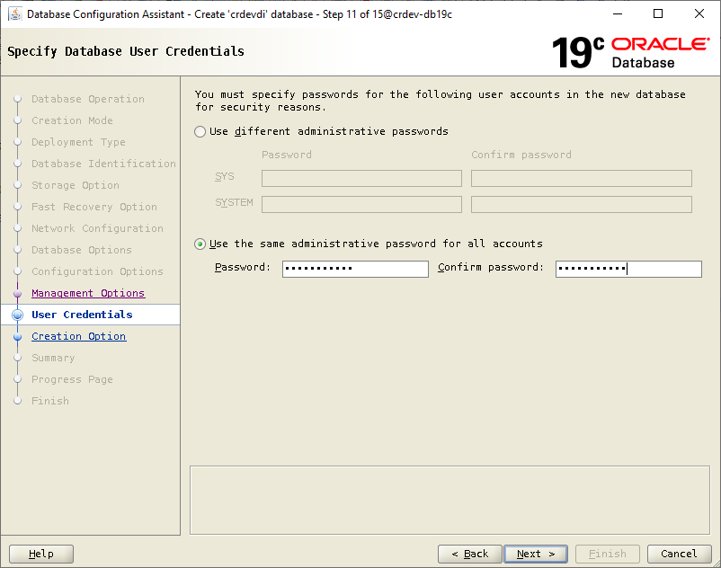

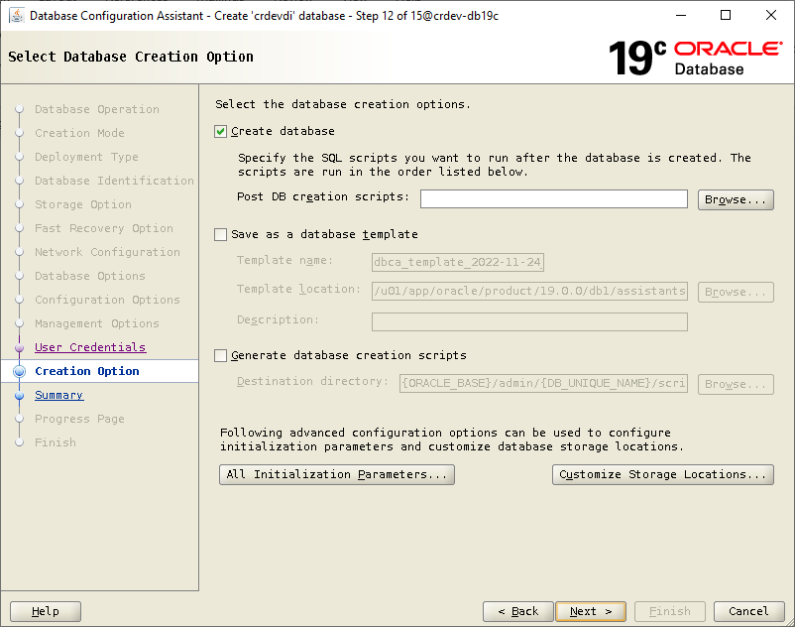

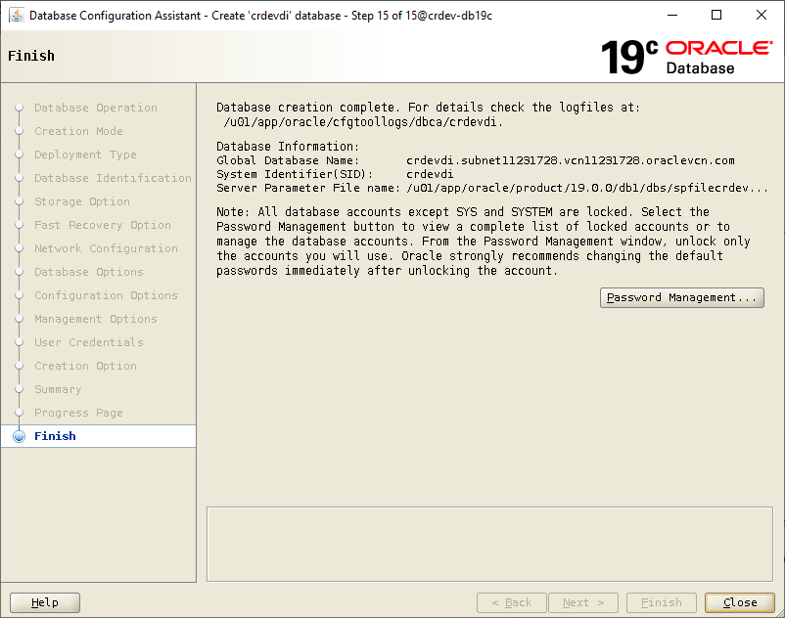

db_create_file_dest string /u02/oradata/

SQL> alter system set db_create_online_log_dest_1='/u02/oradata/' scope=both;

SQL> create tablespace convertrite datafile size 5G autoextend on next 1G maxsize unlimited;

SQL> create USER CONVERTRITE identified by CONVERTRITE

DEFAULT TABLESPACE convertrite TEMPORARY TABLESPACE "TEMP" ACCOUNT UNLOCK;

**QUOTAS :**

SQL> ALTER USER CONVERTRITE QUOTA UNLIMITED ON convertrite;

**SYSTEM PRIVILEGES :**

GRANT CREATE TRIGGER TO "CONVERTRITE" WITH ADMIN OPTION;

GRANT CREATE MATERIALIZED VIEW TO "CONVERTRITE" WITH ADMIN OPTION;

GRANT DEBUG ANY PROCEDURE TO "CONVERTRITE" WITH ADMIN OPTION;

GRANT CREATE VIEW TO "CONVERTRITE" WITH ADMIN OPTION;

GRANT CREATE SESSION TO "CONVERTRITE" WITH ADMIN OPTION;

GRANT SELECT ANY TABLE TO "CONVERTRITE" WITH ADMIN OPTION;

GRANT CREATE TABLE TO "CONVERTRITE" WITH ADMIN OPTION;

GRANT CREATE TYPE TO "CONVERTRITE" WITH ADMIN OPTION;

GRANT SELECT ANY DICTIONARY TO "CONVERTRITE" WITH ADMIN OPTION;

GRANT CREATE PUBLIC SYNONYM TO "CONVERTRITE" WITH ADMIN OPTION;

GRANT CREATE SYNONYM TO "CONVERTRITE" WITH ADMIN OPTION;

GRANT EXECUTE ANY PROGRAM TO "CONVERTRITE" WITH ADMIN OPTION;

GRANT CREATE SEQUENCE TO "CONVERTRITE" WITH ADMIN OPTION;

GRANT CREATE DATABASE LINK TO "CONVERTRITE" WITH ADMIN OPTION;

GRANT DROP PUBLIC SYNONYM TO "CONVERTRITE" WITH ADMIN OPTION;

GRANT CREATE PROCEDURE TO "CONVERTRITE" WITH ADMIN OPTION;

GRANT execute ON DBMS_LOCK TO convertrite;